**CSAP - Days Elapsed (ver B)**

Write a program that calculates the number of days elapsed given the beginning month number and day number and ending month number and day number within the same year. Include in the calculation of elapsed days, whether the current year is a leap year and range of months contains February. The number of days includes the start date and the end date (ie. sample 5). Error checking should include verifying if the day is valid for the month (ie. 9/31 is not valid) and if the start date is before the end date (ie. sample 4). If there is an error allow the user to re-enter data.

Use the following conditions for leap year: (<https://www.mathsisfun.com/leap-years.html>) 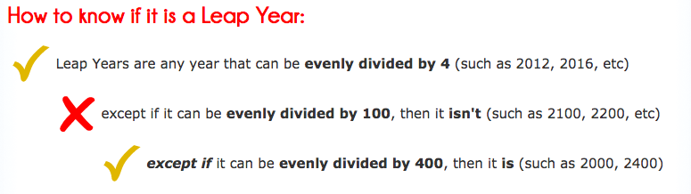

|  |  |  |  |
| --- | --- | --- | --- |
| **Sample 1:**  Enter  year: 2016  start month: 3  start day: 3  end month: 5  end day: 25  Elapsed days: 84 | **Sample 2:**  Enter  year: 2016  start month: 1  start day: 10  end month: 2  end day: 17  Elapsed days: 39 | **Sample 3:**  Enter  year: 2015  start month: 2  start day: 1  end month: 3  end day: 1  Elapsed days: 29 | **Sample 4:**  Enter  Year: 2015  start month: 12  start day: 1  end month: 11  end day: 25  Elapsed days: error |
| **Sample 5:**  Enter  year: 2017  start month: 10  start day: 3  end month: 10  end day: 4  Elapsed days: 2 |  |  |  |

**Program must include:**

1. Getting input from user
2. Error checking
   1. dates given are valid (ie 9/31 not valid). If not, reprompt for valid date
   2. start date is before end date. If not, restart entire input process
3. Calculating the days elapsed. There are 3 cases
   1. if difference in months == 0
   2. if difference in months == 1
   3. if difference in months >= 2
4. Print results